[header]

Dear Ambassador Greer,
The National Association of Manufacturers is the voice of the manufacturing community and the leading advocate for a policy agenda that supports and empowers the 13 million people who make things in America. As the largest manufacturing association in the U.S., the NAM’s membership includes businesses of all sizes, across all industrial sectors, and in all 50 states. Manufacturers collectively contribute $2.93 trillion to the U.S. economy and accounts for nearly 53% of all private-sector research in the nation.
The NAM appreciates the opportunity to provide comments on the forthcoming six-year review of the United States-Mexico-Canada Agreement (USMCA). As USTR prepares for the review process, the NAM encourages the Administration to focus on improvements to strengthen the Agreement and address the challenges posed by non-market economic rivals like China while retaining the core benefits that have been a boon for American manufacturing.
American Manufacturing is the Engine of the U.S. Economy
The strength and the vibrancy of the U.S. economy depend on the competitiveness of U.S. manufacturing. Every job in manufacturing creates four others. Every dollar invested in our sector adds more than two and a half dollars to the broader economy. More than half of all private-sector research and development in the United States happens on the factory floor. Manufacturing makes up a disproportionate share of capital stock and productivity growth. Bottom line – when American manufacturers win, America wins.
The Administration has rightly pursued a comprehensive manufacturing strategy. Implementing the President’s tax reforms, unblocking permitting approvals, rebalancing regulations, and making investments in the American manufacturing workforce are all vital to achieving a renaissance in American manufacturing. The USMCA, as modernized and improved during the first Trump administration, not only supports manufacturing at home and for the North American market, it is also a core driver of the global competitiveness of manufacturers in the U.S.
The Powerhouse that is North American Manufacturing
If American manufacturing were a country, it would be the eighth largest economy in the world. As strong as the U.S. is alone, together with Mexico and Canada, North America accounts for one-third of global GDP. That is nearly double China.
The North American co-production model enabled by the USMCA has boosted American manufacturing to unparalleled levels, with value-added manufacturing hitting an all-time high of nearly $3 trillion in 2024, accounting for nearly 10% of value-added output in the U.S. economy. Total U.S. manufacturing exports reached $1.6 trillion in 2024.
USMCA unlocks the full opportunity of the natural trading relationships among three large countries that share borders. In 2024, the total value of goods and services trade among the U.S., Mexico and Canada was about $1.5 trillion – the equivalent of $3.6 million in transactions in North America every minute. For this reason, the NAM seeks to work with the Administration to assure there is no disruption to the deeply integrated and beneficial co-production model that underlies the operations of most manufacturers in the U.S.
At the same time, it is an economic relationship that must be continually nurtured and upgraded to ensure the agreement remains the strongest in the world and its benefits are fully extracted by the manufacturers that are the most competitive in the world. There is no doubt the USMCA is a ballast in a turbulent global economy if we ensure coordinated approaches to safeguarding the North American market against unfair trading practices.

USMCA is a Manufacturers Trade Agreement
The USMCA is the most pro-manufacturing trade agreement in history. Through complementary cross-border commercial relationships and investments, U.S.-based manufacturers leverage unique and complementary regional assets to effectively outcompete all other major economies, including China.
In the face of geopolitical instability, the drive to win the technological race, the imperative of energy dominance, workforce challenges and other headwinds, the enduring advantage of geography persists, and by utilizing the opportunity of the USMCA, manufacturers structure their operations to maximize U.S. strengths in R&D, product development and process innovation and increase productivity and returns.

The Gears of Regional Production
Manufacturers in U.S. excel in R&D and design-driven activities, including innovation in everything from pharmaceuticals and life-saving medical devices to next-generation digital technologies. Manufacturers in the U.S. also lead “learning-curve” activities from precision tools to semiconductors production which require significant investments of capital, time, and engineering to achieve exponential process improvements and productivity gains.
Manufacturing innovation in the U.S. delivers market-leading, differentiated products. Scaling to meet consumers demand often relies on regional production. North American co-production enables manufacturers in the U.S. to scale and achieve resiliency while also remaining agile to customize production and fill orders rapidly through proximity to our own home market or exported to global markets with high U.S. content. Inputs, parts, components and sub-assemblies move across our northern and southern borders several times among OEM and Tier 1, Tier 2 and Tier 3 suppliers in a well-oiled sequence honed through decades of supply chain optimization throughout North America.
The foundation of this model is significant cross-border manufacturing investment through which suppliers are acquired, subsidies formed, and access to natural resources and critical inputs secured. U.S. investors hold $116.3 billion in foreign direct investment (FDI) assets in manufacturing in Canada and over $63 billion in Mexico. U.S. investors hold over one third of FDI stock in Mexico – far above competitors like China. These investments deliver strong returns while making manufacturers more competitive. The U.S. is also now the largest destination for investment from Mexico and Canada. Capital investment in the region grew 134% since the implementation of the USMCA and now stands at $219 billion.

The Dominant Trading Relationship
Since implementation of the USMCA, Mexico and Canada have surpassed China as the U.S. top trading partners, together accounting for about one-quarter of U.S. exports and about one-third of U.S. imports. There is no more important region for U.S. manufacturing trade and none more symbiotic, characterized by longstanding supplier networks, complementary production activities, and a high degree of related party transactions – U.S. manufacturers have significant operations throughout the entire region.
Bigger Home Advantage – Sales at Home and Throughout North America: Over XX% [pending updated figures] of manufacturing output in the U.S. in 2024 was sold in the U.S., Canada and Mexico. Canada and Mexico’s purchases of one-fourth of U.S. manufactured goods exports in 2024 were more than the next ten U.S. trading partners combined.
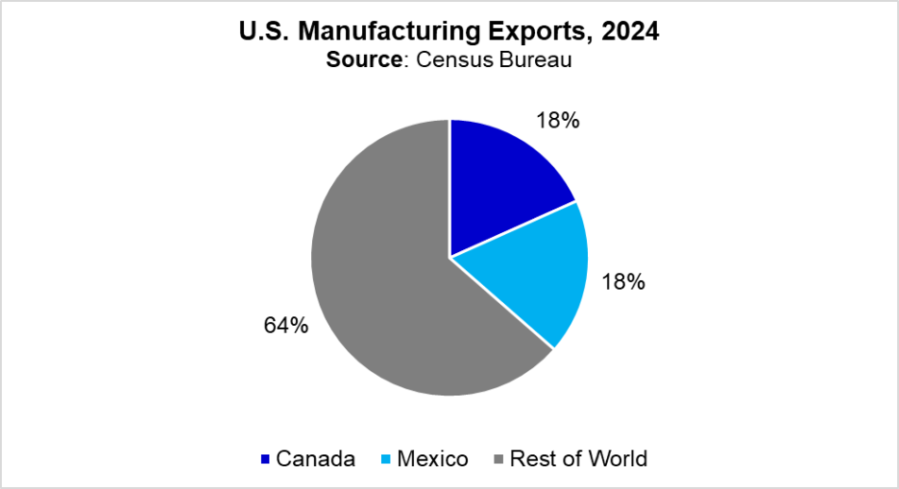
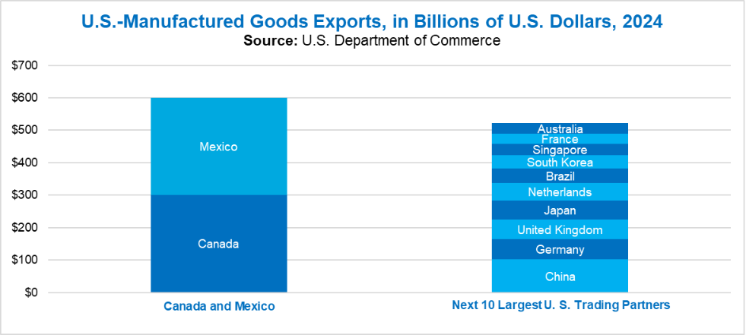
Most U.S. manufacturing sectors count Canada and Mexico as their top sales markets. [pending data on # of sectors that have CA/MX as top markets] Over the last 10 years, many manufacturing sectors saw the best export performance with Mexico and Canada compared to the rest of the world.

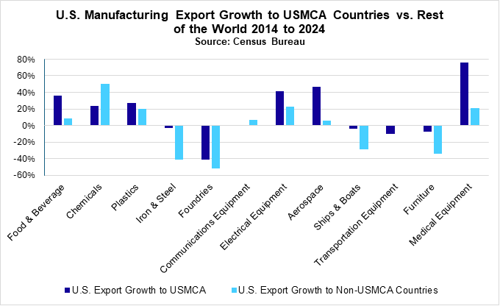
Reliable Source of Manufacturing Inputs: Mexico and Canada are also major sources of intermediate goods and capital equipment for manufacturing in the U.S. Seventy-two percent of imports from Canada and 63% of imports from Mexico are industrial materials, parts, and components that go into further manufacturing in the U.S. and the machinery and equipment installed in American factories.
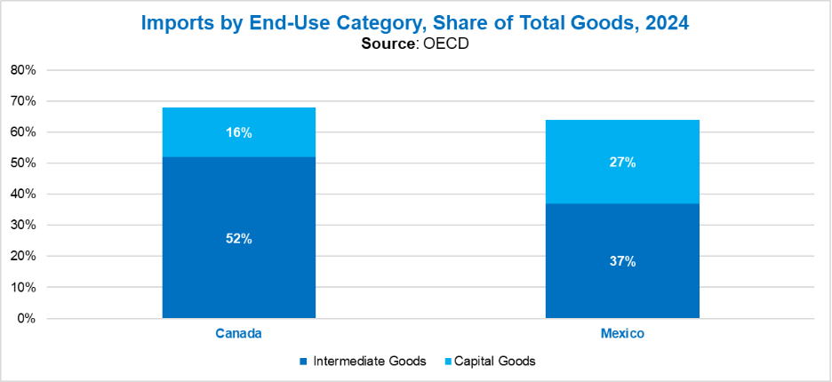
Sales To and From Related Parties: These inputs help power America’s manufacturing might. A significant proportion of U.S. manufacturing trade with Canada and Mexico is conducted by “related parties” – businesses owned wholly or partially by the same parent company. These transactions account for nearly $200 billion in U.S. exports and over $400 billion in U.S. imports. In some high-performance sectors like automotive and aerospace, these transactions account for 76% of U.S. trade with Mexico and Canada. For goods like electrical equipment, appliances, and computers, the share is also high at 65%.
This translates into substantial U.S. content in manufactured imports coming into the U.S. from Mexico and Canada. Related party trade also supports U.S. exports of manufactured goods to markets around the world.
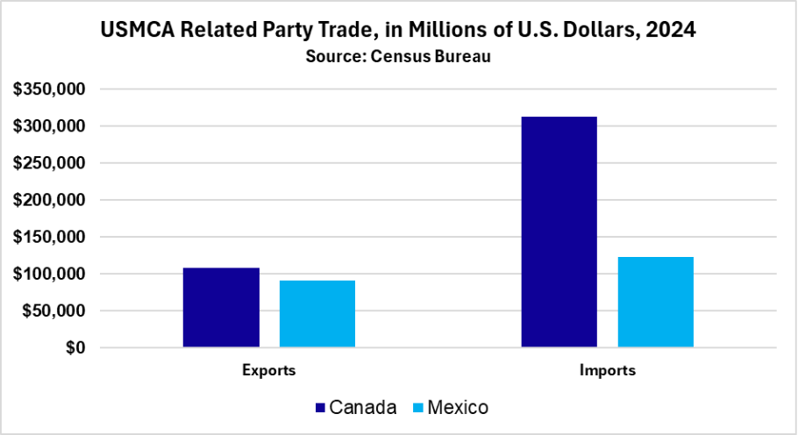

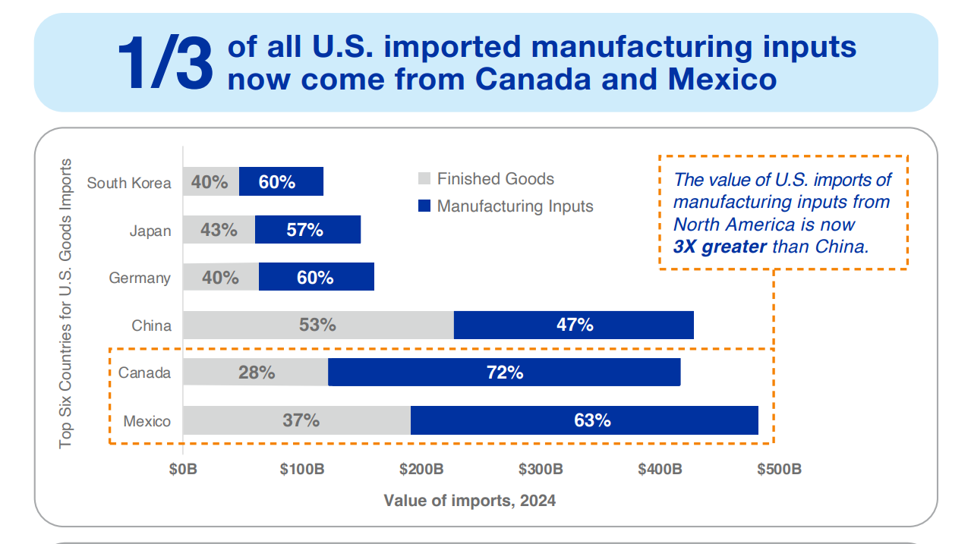
Nearshoring from China: As the U.S. re-aligns its economic relationship with China, the USMCA has enabled Mexico and Canada to replace China as the U.S. top trading partners, with imports from Mexico growing as imports from China have fallen. The value of imports of manufacturing inputs from North America is now three times greater than from China. And goods produced in Mexico for export to the United States typically contain about 40% U.S. content (25% from Canada), versus 4% U.S. content in imports from China.
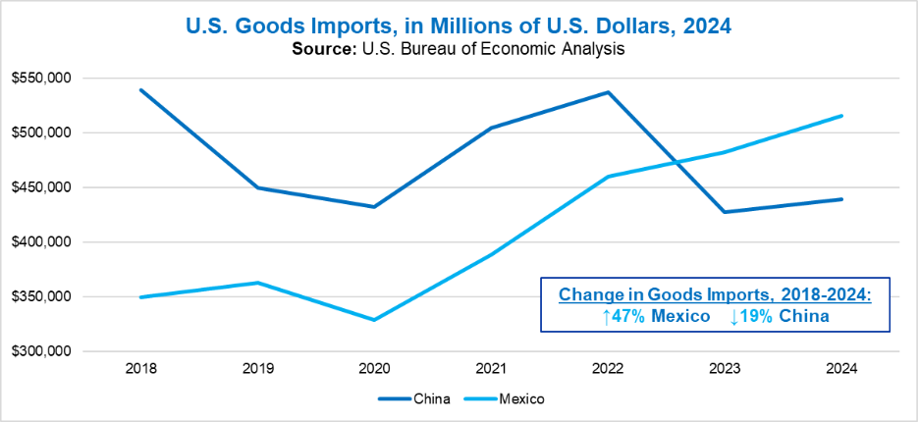
Supporting U.S. Manufacturing Jobs: Economic integration in North America supports American jobs. Exports to Mexico and Canada support nearly 2 million American workers, and U.S. global exports of manufacturing – achieved in part by the competitive edge enabled by cross-border production networks – support 5 million American workers.
This model not only employs Americans – it helps make America more productive and competitive. The U.S. leads in real manufacturing value-added per worker, a critical asset against large competitors. For example, U.S. manufacturing workers are nearly 6 times more productive than a Chinese manufacturing worker, while U.S. firms also spend more on R&D than the Chinese firms. As manufacturers look to compete, the productivity advantages, supported by preferential trade and investment with Mexico and Canada under USMCA, remain critical to preserve and enhance.

NAM Recommendations for USMCA Review
Assure Operational Continuity
Geographic proximity with Mexico and Canada provides a unique combination of reliability and resilience for American manufacturing and its supply chains. For manufacturers in the U.S. who compete globally and who are critical suppliers to those who compete globally, leveraging fully the assets and strengths of the North American platform is central to weathering economic and non-economic vulnerabilities in today’s global economy. In grappling with geopolitical risks and the mounting impacts of non-market unfair trade practices, manufacturers prioritize security and reliability of supplier networks over low-cost considerations. With partners in Mexico and Canada, the bonus is achieving these long-term security benefits while also shortening supply chains. Just as the overriding goal of manufacturers is to assure and optimize continuity of their operations, the objective of the USMCA review should be the same. The review provides an opportunity to make process improvements while assuring continuity.

Troubleshooting to Make Process Improvements
Cut Red Tape at the Border: Procedures at the border can be further streamlined to ensure timely delivery of critical industrial inputs for manufacturing expansion in the U.S. Although this should be an ongoing initiative pursued by the parties through various customs-related committees and working groups, the review provides a focused opportunity to discuss how to standardize and digitize customs forms, automate compliance procedures, and develop processes for working with the private sector to identify and address bottlenecks at the border as they arise. The NAM also recommends continuing to exempt USMCA-compliant goods from Merchandise Processing Fee.
Digitize Certificates of Origin: Certificate of Origin (COO) documentation is required to demonstrate regional content to obtain USMCA preferences. Prior to the imposition of IEEPA and Section 232 tariffs, many companies – particularly small and medium manufacturers (SMMs) that serve as tier 2 suppliers or tier 3 suppliers – meet the content requirements but have not needed to file paperwork to claim preferences, which can be a significant administrative burden on SMMs.
For example, research by the Federal Reserve estimated the cost of USMCA sourcing documentation requirements as equivalent to a 1.5 to 2.4 tariff increase. By some reports, only 50% of imports from Mexico and 38% of imports from Canada – including many USMCA eligible products – claimed preferences under the agreement in recent years, in large part due to these compliance burdens. The rates are not indicative of the ability of manufacturers today to comply with the rules of origin (ROO), but rather an indication of underutilization of the agreement’s rules of origin. Rather than change rules of origin, greater usage of the agreement could be achieved and documented by working through digital means of providing secure data to prove compliance.
Seek Input on Refining Rules of Origin: USMCA ROO can be complex depending on the product. The rules work very well in most cases and should be continued, for example the chemical reaction rule and the use of a simple tariff shift rule for most non-automative USMCA goods. In some cases, manufacturers see room for very targeted improvement. For example, “substantial transformation” for ROO purposes typically requires a tariff shift at the chapter level, but in some cases, this may not be appropriate. Cocoa – which is not grown domestically in meaningful quantities, is imported into and processed in North America, but these processed products fall under the same HTS chapter. Allowing targeted tariff shifts at the heading level would allow these processed cocoa products to qualify for USMCA preferences.
[Additional examples from members if appropriate]
The NAM also strongly recommends detailed consultations with manufacturers regarding any proposed changes to ROOs, which if considered, should be marginal and implemented with appropriate phase-in periods.
Protect Cross-Border Investments: Energy is a critical input for manufacturing. From AI data centers and semiconductor fabs to steel mills and auto plants, manufacturing requires access to affordable, reliable energy, and demand will only increase.
At this pivotal moment, however, a challenging investment climate remains a major impediment to deploying energy assets in Mexico. Constitutional reforms have enshrined the privileged position of PEMEX and CFE in Mexico’s energy market and undermined the impartiality of the judiciary in adjudicating commercial disputes. Many of the problems raised during the 2022 consultations under USMCA over Mexico’s energy policies have only worsened. For many American energy producers and distributors, Mexico is practically closed for business. The U.S. Government should promote strong protections for U.S. cross-border investment in energy to power American manufacturing in Mexico and the U.S. Investor rights should be pursued in state-to-state dispute settlement but also by expanding the opportunity to use Investor-State Dispute Settlement (ISDS), given the worsening ability to pursue private rights of action through Mexico’s legal system.
Prevent SOEs From Stifling Private Enterprise: Unfair competition with state-owned enterprises (SOEs) leads to inefficiency and lost commercial opportunities for U.S. manufacturers. Mexico’s energy SOEs, PEMEX and CFE, are case in point, with low performance, mounting debt, and preferential government treatment crowding out private investment – to Mexico’s own detriment and to the detriment of U.S. investors in Mexico who rely on energy for their operations. This comes at a time when every electron is needed to power the race to AI dominance and the manufacturing renaissance.
NAM supports strengthening SOE provisions in USMCA to ensure private enterprise can thrive alongside SOEs in Mexico or Canada and to ensure upgraded provisions address the practices of non-Mexican and non-Canadian SOEs. These should include provisions to address non-commercial assistance provided to SOEs that enable commercially unviable investments, extending disciplines to private enterprises that receive non-commercial assistance from SOEs themselves, and expanding disciplines specifically for energy sectors, including exploration, refinement, and retail for oil and gas as well as electrical generation and transmission. The NAM would like to work with USTR to further develop these ideas.

Standard Operating Procedures with Real-time Feedback Loops
To stay best in class, the parties, in regular consultation with manufacturers, should discuss process improvements that keep the North American manufacturing gears turning. In the lead up to the review, governments will undertake bilateral commitments to implement and improve the functioning of the agreement. This should be standard operating procedure versus an annual conversation. Manufacturers stand ready to provide real-time feedback loops so that the parties can keep the agreement in good working order.
For example, the U.S. should propose quarterly meetings among the parties with the private sector to discuss technical regulations, standards and conformity assessment issues that are emerging and could be addressed before they become barriers to North American trade. In recent years, not all three countries were willing partners, but this is easily remedied with political commitment. Similarly, the USMCA established dozens of working groups and committees that remain underutilized but that would provide for continual maintenance without requiring these issues be undertaken in any annual review.
They include standing groups to discuss customs cooperation, intellectual property protections, implementation and expansion to the sub-central level of state-owned enterprise commitments, and the functioning of rules of origin. For many of these topics, it would be beneficial to discuss obstacles to full utilization of the agreement by stakeholders and include opportunities for stakeholder dialogue. By enabling input from the private sector, the agreement can remain evergreen and responsive to constantly changing business conditions. It is unclear whether or how often some increasingly important groups meet. For example, given the deteriorating legal environment in Mexico, the parties should activate and use the Advisory Committee on Private Commercial Disputes to promote more effective resolution of international commercial disputes between private parties in the USMCA free trade area. The parties, working with the private sector, could also building on past efforts to coordinate on responses to emergencies by jointly identifying, preparing for, and mitigating the impacts of supply chain disruptions.

Staying Agile – Building on the USMCA
North American Cooperation in Energy and Critical Minerals
Manufacturers utilize critical minerals extensively, deploying them in a wide array of manufactured products throughout the U.S. economy—including in aircraft and defense systems, in automotive parts and vehicles, in electric grid components, in robotics and industrial automation, in personal electronics, and much more. Despite our abundant domestic sources, the U.S. remains highly import reliant for many of the critical minerals identified by the U.S. Geological Survey, with China as the primary source for key minerals including tantalum, tungsten, germanium, zinc, gallium, graphite and rare earths elements (REEs), among others.
As the Administration advances action, such as permitting approvals, to ramp up domestic production of critical minerals, Mexico and Canada can supplement these efforts by providing their own unique endowments of natural resources required for more manufacturing in the U.S. Canada is a major producer of several critical minerals the U.S. currently imports from China, while Mexico holds abundant reserves in minerals including silver, zinc, lead and copper.
The NAM supports developing a critical minerals agreement as a corollary to the USMCA review with the goal to expand production and processing of critical minerals and develop integrated North American critical mineral supply chains.
Ensure USMCA Tariff-Free Trade in Critical Minerals: The NAM supports maintaining duty-free trade in critical minerals and related products under USMCA. This will ensure manufacturers have reliable, secure, and cost-effective access to critical inputs and support the scaling of U.S. domestic mining and processing projects.
Align Regulatory Frameworks to Accelerate Investment: The NAM recommends negotiating commitments to align regulatory approaches related to mining and processing critical minerals. This could include sharing best practices from the Administration’s recent progress on permitting reform and rolling back restrictive policies like those in Mexico’s move to nationalize lithium mining and current freeze on new mining concessions.
Catalyze Cross-Border Investments in Critical Minerals Projects: The NAM supports securing beneficial foreign direct investment terms under USMCA to catalyze investment in critical minerals projects across North America. These could include mechanisms to pool public and private capital among USMCA countries to co-invest in projects, paired with long-term offtake agreements to provide a clear market signal. Recent initiatives within the U.S., such as the Defense Department’s investment and purchase commitments with MP Materials (REEs) and the Energy Department’s co-investment in the Lithium America’s Thacker Pass lithium mine, can serve as models.
Likewise, the three governments should explore mechanisms to align efforts across U.S., Mexico and Canada on accelerating the life cycle for critical mining projects, such as ongoing and proposed efforts by EXIM Bank and the U.S. Development Finance Corporation to conduct feasibility studies, map resources, and de-risk private capital through loan guarantees, equity investments, and political risk insurance. As the Administration looks to utilize the Defense Production Act to advance critical minerals projects pursuant to EO 14241, the three governments as a corollary to the USMCA review should also look for ways to facilitate joint projects like Fireweed Mactung tungsten mine, jointly funded by the U.S. Defense Department and Canadian Department of Natural Resources.
Coordinate Stockpiling and Align Government Procurement: Stockpiling critical minerals in strategic reserves can serve the dual purpose of providing a safety valve against disruptions of supply in times of crisis while also sending a market signal to further accelerate investment. In both instances, pooling resources among the U.S., Mexico and Canada can get more bang for our bucks. Likewise, aligning government procurement of critical minerals, including exploring joint procurement projects, can ensure maximum impact in supporting expanded capacity while avoiding bidding wars. The NAM supports leveraging institutional structures under the USMCA to facilitate coordination on stockpiling and procurement to support North American critical minerals production.
Establish a Critical Minerals Initiative under the North American Competitiveness Committee: Accelerating the lengthy process of opening a mine or bringing online critical mineral processing capacity requires creative ideas and close coordination with the private sector. This is exactly the kind of initiative the NACC was designed to undertake. The NAM recommends establishing a designated critical minerals initiative under the NACC with the mission to identify bottlenecks and limiting factors that are holding back North American critical minerals production. This initiative should ensure active and ongoing engagement with the private sector, and the NAM stands ready to facilitate through regularly (e.g. quarterly) workshops with manufacturers.

Promoting a North American AI Platform
The race for global AI dominance is on, with the U.S. and China locked in a competition for who will develop the most innovative and transformative – and dominant – models. Manufacturing is at the core of this competition, from the GPUs and printed circuit boards that fill AI data centers to the electrical generation, transmission, and transformers that power these models.
In addition, manufacturers are important adopters of AI. Manufacturers use AI to make factory floors safer, to accelerate the rate of product and process improvements for better, cheaper products, and to ensure real-time visibility throughout facilities and supply chains to catch malfunctions or stoppages as soon as, or even before, they happen.
To win the AI race, the NAM recommends leveraging the USMCA to ensure American innovators can draw on the collective strength of the U.S., Mexico and Canada.
Protect and Strengthen Digital Trade Provisions: USMCA contains best in class provisions to protect the flow of data among North America. These provisions need to be vigorously enforced. The flow of data, particularly industrial data, is critical for manufacturers, particularly as they work to gain better visibility into their supply chains. The NAM supports retaining, and where possible strengthening, the digital trade provisions under USMCA.
Invite Mexico and Canada to Join the AI Action Plan: The NAM strongly supports the AI Action Plan released by the White House in July 2025 and the Administration’s goal to promote the export of a globally competitive American AI tech stack. Mexico and Canada can serve as partners in this endeavor, including providing key inputs (e.g. energy, capital goods, training data) to build out the strongest stack possible. As part of the USMCA review, the NAM recommends formally inviting Canada and Mexico to sign on to the AI Action Plan, and to establish a mechanism under the North American Competitiveness Committee to facilitate cooperation on building a North American AI tech stack.

Building the Defense Industrial Base Through North America
Manufacturing is not just about commercial success – it is about national security. From the equipment that protects America’s warfighters to advanced weapons platforms that protect the homeland, American manufacturers make the U.S. safer.
During the second world war, American industry earned the nickname the “arsenal of democracy,” but importantly we were not alone. That arsenal was built with the support of our neighbors in Mexico and Canada, providing critical materials and workforce to produce the weapons that beat the Axis.
As the U.S. looks to revitalize its defense industrial base amid an increasingly complex geopolitical landscape, the NAM recommends exploring ways to leverage North American supply chains to build a stronger, more innovative, and more resilient twenty first century arsenal of democracy.

Quality Control: Maximizing USMCA Benefits for Manufacturers
A North American Approach to Address Unfair Trading Practices by Non-Market Economies
Economic security is a regional matter. The USMCA contains the most advanced provisions of any free trade agreement in the world when it comes to addressing unfair trade practices by non-Parties to the agreement. But more can be done to establish an effective enforcement baseline and ensure that the benefits of the USMCA accrue to the Parties and benefit manufacturers with investments and operations throughout the region.
Effective Measures to Address Artificially Cheap Goods: The NAM supports robust and effective enforcement of anti-dumping and countervailing duty laws to ensure subsidized and artificially cheap goods, particularly from non-market economies, do not flood the U.S. market at the expense of our manufacturing base. Given the well-documented challenge of circumvention of AD/CVD measures, the three governments could explore commitments to increase confidential information sharing pertinent to AD/CVD investigations and establish automatic triggers to launch an investigation if one country does so. This could ensure that the deliberative, evidence-based approach to AD/CVD investigation and enforcement moves faster and avoids gaps that bad actors can exploit.
Work Together to Combat Transshipment and Misclassification: The benefits of USMCA should accrue to manufacturers and workers from America, Mexico and Canada. While USMCA has borne fruit for manufacturers in the U.S., the USMCA review could be used to better understand whether there are loopholes that competitors exploit to gain access to the U.S. market, including through “ghost mills” and customs fraud.
The NAM supports establishing a joint working group with Mexico and Canada to combat transshipment and misclassification. This working group should focus on increasing effective enforcement against outright customs fraud, such as through information sharing between authorities and coordinated operations. These efforts should avoid administratively burdensome requirements on good actors, which would raise compliance costs while doing little to address the problem.
Develop a Coordinated Approach to National Security Tariffs: As the Administration works to address national security concerns, the NAM recommends treating Mexico and Canada as trusted partners, leveraging the USMCA review to strengthen coordination and address shared vulnerabilities. For example, the governments could explore ways to coordinate national security trade actions, so that if one country identifies a national security threat from imports, all three countries can jointly respond while maintaining uninterrupted trade within USMCA. Having established those joint measures and having implemented common measures to prevent transshipment and customs fraud, the U.S. should not maintain unilateral national security tariffs on qualifying goods under USMCA.
Work Together to Screen Investments for Security Risks: In recent years, policymakers have grown increasingly aware of the potential security risks posed by certain foreign investments, such as to acquire innovative technologies with potential military or intelligence applications or access user data for potential surveillance. The U.S. and Canada already screen foreign investments for national security concerns, and Mexico is considering its own measures.
These efforts could be more effective through greater coordination, such as information exchange or joint notification mechanisms, to ensure these investments, particularly those utilizing complicated or opaque ownership structures, do not bypass screening from any individual country. NAM recommends exploring closer cooperation on investment screening under USMCA to ensure American manufacturers can build their supply chains without concerns about investments, for example, by state-owned or state-directed enterprises, creating vulnerabilities.

Troubleshooting Operational Issues in Mexico and Canada
Address Concerns with SAT: Manufacturers are increasingly reporting aggressive tactics by the Mexican tax authority, Servicio de Administración de Tributaria (SAT), including excess and unwarranted audits, challenging of USMCA certificates of origin, and revocation of import licenses and VAT certifications for routine paperwork errors, all while allowing minimal time for corrections. It has become routine to charge exorbitant – and often retroactive – tax bills as penalties without appropriate paperwork. The NAM recommends USTR investigate these issues to ensure that efforts to enforce compliance with Mexican tax and customs laws are neither discriminatory nor invalidate the benefits of the agreement.
Ensure the integrity of IMMEX: Manufacturers utilizing the Industria Manufacturera, Maquiladora ye de Servicios de Exportación (IMMEX) program report that recent modifications are undermining their ability to participate. The Mexican government has introduced onerous requirements, including requiring participants to grant online and real-time access to company inventory management systems. These intrusive and excessive disclosures have led many companies to exit the program, and difficulty with compliance recently led the Ministry of Economy to cancel certifications en masse.
Improve Customs Processes: Cutting red tape and minimizing delays at the Southern border supports manufacturers in the U.S. by ensuring timely delivery of critical inputs. Despite commitments on trade facilitation and customs cooperation under USMCA, manufacturers experience long delays due to exhaustive and inefficient inspections by Mexican customs authorities. Mexico has also failed to implement certain commitments under USMCA Chapter 7 on Trade Facilitation, including by limiting the number of ports that customs brokers can operate in, disregarding the “communication with traders” provisions of the chapter, and failing to implement a periodic payment option for express delivery. The USMCA envisioned routine and robust discussions among the parties through the Committee on Trade Facilitation (Article 7.24) to address measures inconsistent with USMCA obligations, and to reduce friction at the border that undermines the agility of North American manufacturing supply chains.
Reduce Barriers to U.S. Medical Device and Pharmaceutical Exports: Manufacturers in the U.S. lead the world in the research, development, and production of innovative pharmaceuticals and medical technologies, but Mexico’s inspection and import permit requirements continue to pose market access barriers for U.S. exporters. Import delays that stretch years undercut U.S. exports and market share while ultimately denying timely access of health care technologies to patients in Mexico. Mexican regulator COFEPRIS recently enacted simplified and streamlined requirements for medical devices and pharmaceuticals. This is a good first step. The Parties should deepen cooperation under Annexes 12-E and 12-F to ensure competitive market access for U.S. medicines and medical technologies.
Roll Back Restrictions on American Investment in Mining: The USMCA can provide a catalyst to build out critical mineral supply chains across North America. These efforts are hamstrung by restrictions in Mexico on mining, particularly the nationalization of lithium resources – a critical material for batteries and energy systems – and limitations on private companies on the exploration and utilization of these resources. This follows a similar story to PEMEX in the oil and gas sector. Mexico should roll back these restrictions, opening lithium mining up to private enterprise, including U.S. manufacturers, to more efficiently unlock these resources.
Fully Protect U.S. Intellectual Property Rights: Mexico passed the Federal Law for the Protection of Industrial Property (LFPPI) in July 2020 as part of a package of five bills to implement USMCA provisions. However, to date the Mexican Institute of Industrial Property (IMPI) has not issued the follow-up regulations to implement important intellectual property rights (IP) protections such as patent term adjustment, patent linkage, among others. As a result, manufacturers continue to experience IP violations in Mexico. Marketing authorizations are granted to copycat generic manufacturers without regard to the existence of a valid patent on the product, in violation Article 20.50 and Annex 20-A in the USMCA, which establish standards and obligations for the parties regarding effective patent linkage systems. In some cases, the Mexican government has even proceeded to international tenders of medicines with valid patents. Despite the presentation of direct evidence to Mexican authorities, the infringing companies are still able to participate in government tenders and IMPI is not enforcing its laws or issuing injunctive relief.
There is also a serious backlog at Mexico’s Federal Commission for the Protection against Sanitary Risk (COFEPRIS) for the authorization of clinical trials and approval of new medicines. Years long delays in marketing approval from the Mexican government are a major hurdle for pharmaceutical manufacturers companies operating in the country. Just 25% of new medicines launched globally since 2012 are available in Mexico. Changes made by the current administration are exacerbating delays. For example, approval of Mexico’s New Molecules Committee is now required prior to filing a marketing authorization request, companies report excessive times before approved medicines are included on the public formulary, and the five-year marketing authorization renewal process significantly exceeds its statutory timelines. Mexico’s practices are inconsistent with Annex 12-F of the USMCA, which notes that “[e]ach party shall administer its marketing authorizations reasonably, including by…providing an applicant that requests marketing authorization for a pharmaceutical product with a determination within a reasonable period of time.” Mexico is also missing an important opportunity to attract clinical research into the country because of the length of regulatory approval timing.
Regarding trademark protections, Mexico continues to curtail the use of trademarks related to food and beverage products. In Canada, manufacturers are remain concerned about Section 51.1 of Quebec’s Charter of the French Language (referred to as Bill 96), which mandates significant labeling and packaging changes for manufacturers to include French translations of non-French trademarked items, potentially upending decades of IP law, creating burdens for manufacturers and limiting access to the Quebec market.
Press Canada to Update the CARM Database: NAM members continue to face problems with the Canadian Border Services Agency’s Assessment and Revenue Management (CARM) system, including issues with the availability of import and export data through the system. The NAM recommends raising this with Canada during the USMCA review.
Reduce Federal Carbon Pricing Burden on Critical U.S. Manufacturing Inputs: Canada’s Federal Carbon Pricing scheme raises the cost of producing critical inputs in Canada that support production in the U.S. The fertilizer industry – an important intermediate product in agricultural production and a major export of Canada to the U.S. – will face over $1 billion in added costs over the next 5 years.
[Do members have Canada issues to include? Or additional Mexico issues?]
Respect the Contract
The USMCA is a contract. Contracts can be updated, but the agreed terms should be respected. The NAM appreciates that USTR is pursuing the above issues in bilateral talks and encourages ongoing engagement to troubleshoot and raise issues of continued non-compliance, and if necessary, pursue formal dispute settlement channels to address violations. We support resolution of ongoing disputes such as pertains to the energy sector in Mexico. The U.S. should use all tools available to press Mexico to reverse its energy policies that hamper the ability of American companies to invest and operate in Mexico. These include the issues raised by the U.S. in consultations under USMCA in 2022. Mexico’s decision in 2024 to revert PEMEX and CFE back to “public entities” and grant them preferences over private commercial players runs afoul of USMCA commitments. Likewise, legislation that removed the independence of the Energy Regulation Commission (CRE) and the National Hydrocarbons Commission (CNH), placing their regulatory responsibilities under the political leadership of the Ministry of Energy (SENER), has cast doubts about fair and equal treatment of foreign operators and investors. These are the types of systemic issues that broadly undermine the benefits of the USMCA not only to companies operating in the affected sector, but also for the users of energy and electricity in their manufacturing operations.
[ISDS]
Achieve Policy Goals and Boost Competitiveness
National security tariffs on steel, aluminum, autos and auto parts have been imposed on nearly one-sixth of all U.S. imports from Canada as of July, with additional tariffs on steel and aluminum derivatives, copper, and lumber/furniture products likely pushing that number even higher. Likewise, over a quarter of U.S. imports from Mexico currently face Section 232 tariffs, with that number likely exceeding 40 percent if all pending or ongoing investigations announced to-date result in tariffs.
The benefits of the USMCA for manufacturers in the U.S. who rely heavily on industrial inputs and capital goods from Canada and Mexico as part of the well-established and deep North American co-production platform are substantially eroded and undermined by including Canada and Mexico in the Section 232 tariff regime. With measures in place to tighten AD/CVD circumvention, transshipment and customs fraud, Canada and Mexico should be exempt from these tariffs for all USMCA-qualifying goods.
Using Reviews for Planned and Preventative Maintenance
The bold decision to modernize the NAFTA to ensure best-in-class provisions where U.S. manufacturing leads, from biotechnology to digital technologies and advanced manufacturing, continues to pay off for American competitiveness in global markets.
Every free trade agreement the U.S. negotiates establishes some form of free trade commission, intended to meet annually to discuss operation of the agreement. Markets never stand still. The benefits designed on paper sometimes do not materialize for manufacturers who, for one reason or another, cannot take advantage of the provisions. Governments continue to make domestic policies, sometimes unintentionally disrupting or undermining commitments to other parties of the agreement. Products and processes are innovated that were not contemplated when the deal was done. For myriad reasons, it makes sense for the parties to meet to discuss how well – or not – the agreement is working to achieve both policy goals and the core commercial goals of the agreement for the manufacturers of each party.
Article 34.7 in USMCA recognized that regular, planned maintenance is necessary to keep the agreement humming, to implement planned and preventative maintenance. What should be included in this review is also an effort to measure success by the standards of those it is designed to benefit – for us, this means manufacturers in the U.S. and their partners and investments in Mexico and Canada.
The first joint review offers an opportunity to do that. Above all, evaluating operational performance to optimize benefits should be performed with no downtime. Leaders from Washington, Mexico City and Ottawa should take a hard look at whether the benefits of the agreement are fully accruing to manufacturers large and small in North America rather than third parties to the agreement, how companies across the economy do – or do not yet – utilize USMCA preferences to trade duty free among the parties, and identify bottlenecks that hamper closer regional integration. The Competitiveness Committee should be forward looking about how to maintain energy dominance, lead the AI race, assure access to natural resources and industrial supplies for manufacturing, and outcompete XXX.
Conclusion
The NAM stands ready to support the Administration, including facilitating engagements with American manufacturers to advise on how to make the most pro-manufacturing trade agreement in history even stronger.

National Association of Manufacturers (May 2025), Manufacturing in the United States, https://nam.org/mfgdata/#KeyFacts
Calculations based on Bureau of Economic Analysis (BEA) data, accessed September 29, 2025.
https://www.state.gov/reports/2024-investment-climate-statements/mexico
https://www.dallasfed.org/research/pubs/25trade/a2#:~:text=The%20net%20amount%20rises%20to,40%20percent%20of%20total%20FDI.
https://www.brookings.edu/articles/usmca-at-3-reflecting-on-impact-and-charting-the-future/
Title 19 of USC Chapter 4, Section 1401a (g)(1) of the Tariff Act of 1930, defines related-party trade import transactions between parties with various types of relationships including “Any person directly or indirectly owning, controlling, or holding with power to vote, 5 percent or more of the outstanding voting stock or shares of any organization and such organization.” The Foreign Trade Regulations, 30.1, define a related-party export transaction as one between a U.S. exporter and an ultimate consignee, where either party owns, directly or indirectly, 10 percent or more of the other party. https://www.census.gov/foreign-trade/Press-Release/related_party/techdoc.pdf
NAM analysis of data reported by the U.S. Department of Commerce, accessed at https://www.census.gov/foreign-trade/Press-Release/related_party/index.html
Pia Orrenius, “Economic Outlook Deteriorates Due to COVID-19: Short and Long Run Implications for North American Supply Chains,” Federal Reserve Bank of Dallas, May 13, 2020
NAM calculations based on ILO data accessed September 23, 2025 - https://rshiny.ilo.org/dataexplorer38/?lang=en&id=SDG_0821_NOC_RT_A
https://iri.jrc.ec.europa.eu/data
https://www.federalreserve.gov/econres/notes/feds-notes/trade-compliance-at-what-cost-lessons-from-usmca-automotive-trade-20250718.html
See NAM submission on Critical Minerals 232 for more details.
See NAM statement - https://nam.org/mexico-hampers-critical-minerals-development-32490/?stream=series-input-stories
Based on data from U.S. International Trade Commission. U.S. imports from Canada totaled $44 billion in July 2025, of which $6.2 billion are subject to Section 232 tariffs on steel, aluminum, autos or auto parts.

